LATIHAN 1
Irenia Maisa Kamila
(2506031)
Kelas 2B

Nomor 1. Gambar Binary Tree

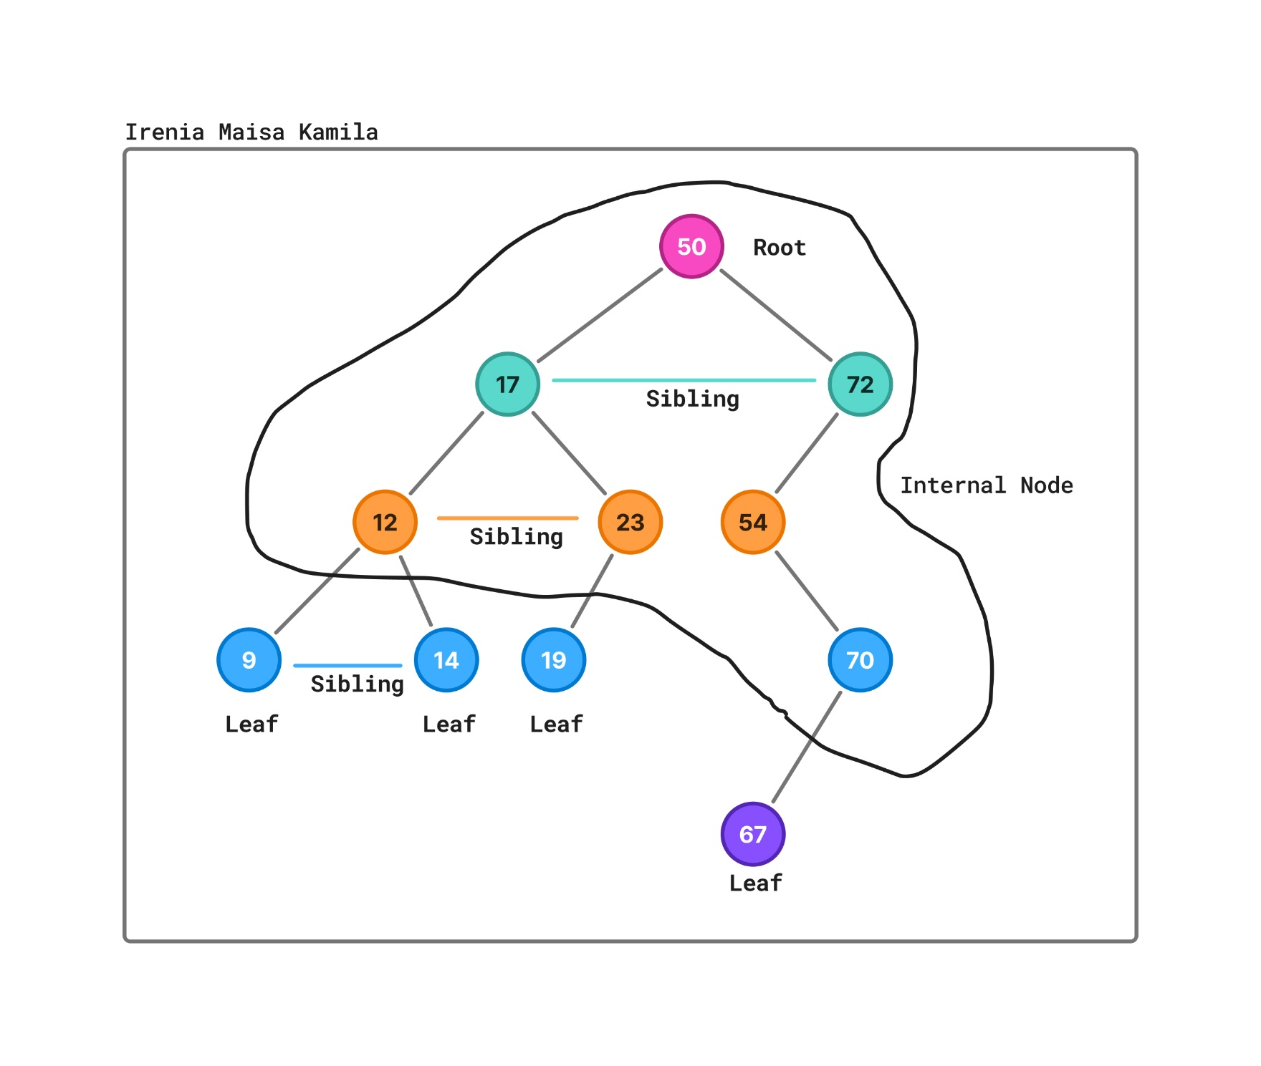

Nomor 2. Root, Leaf, Internal Node, Sibling
Istilah | Node
Root | 50
Leaf | 9, 14, 19, 23, 67
Internal Node | 50, 17, 72, 12, 54, 70
Sibling | (17 dan 72) anak dari 50, (12 dan 23) anak dari 17, (9 dan 14) anak dari 12

Nomor 3. Penelusuran
Jenis | Urutan Node
PreOrder | 50, 17, 12, 9, 14, 23, 19, 72, 54, 70, 67
InOrder | 9, 12, 14, 17, 19, 23, 50, 54, 67, 70, 72
PostOrder | 9, 14, 12, 19, 23, 17, 67, 70, 54, 72, 50

Nomor 4 Bukti no. 3 dengan C++
